Easy Steps to a Successful SNAP
- Send money and commits around & ensure you get daily changes/monthly totals from each region:

NE
S
W
MW
DC
PAC
MOC
DM/ON

- Set up SNAP email.
- Open SNAP email from the previous night
- Reply All
- Bcc’ yourself on new SNAP email
- Ensure the comparison dates on the SNAP match today’s date (i.e. Today is 07/10/13, ensure you have 07/10/12 showing and 07/1/ showing); these are all found in past money in spreadsheets

- Once you receive all regions money in and hard commits, you are ready to do the SNAP! Input each region’s totals/daily changes to the actual Money In spreadsheet, under the Individual Tab. You will put PAC money in the PAC tab and Member, Recount, Victory Fund money under their proper tab. Online and Direct Mail money goes directly on the SNAP tab. Once you do this, ensure that all totals are adding up properly!!

- After all money that was received that day is reflected properly in the Money In spreadsheet, you are ready to do the daily change. This reflects where we were yesterday compared to where we are today. To do this, you want to hide all the SNAP (in blue) until you get to yesterday’s SNAP. Keep yesterday’s SNAP open and then hide until you get to the Daily Change Chart (in pink). Complete the daily change and copy & paste the chart into the SNAP email.
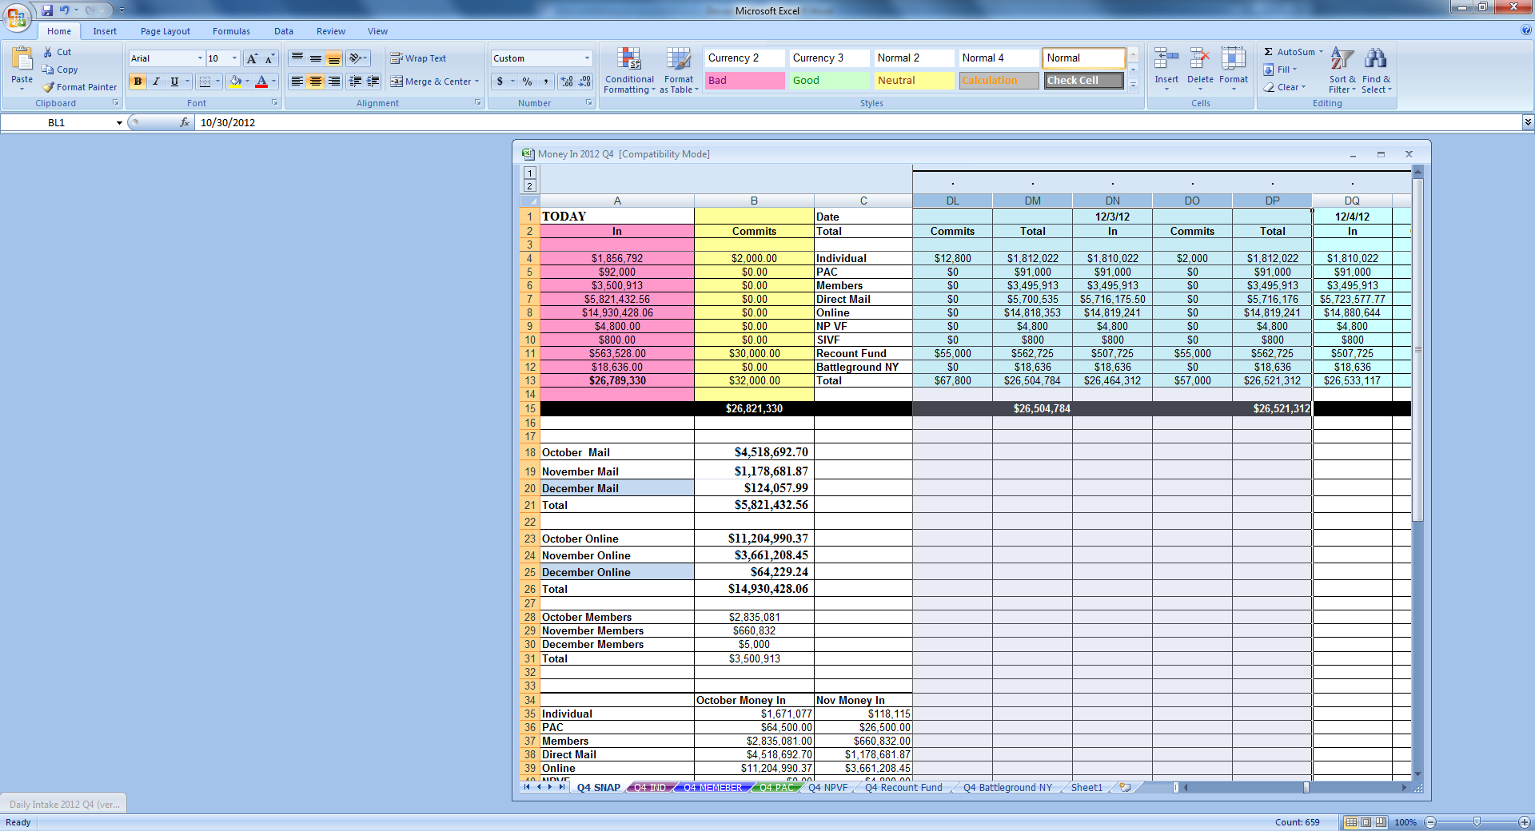

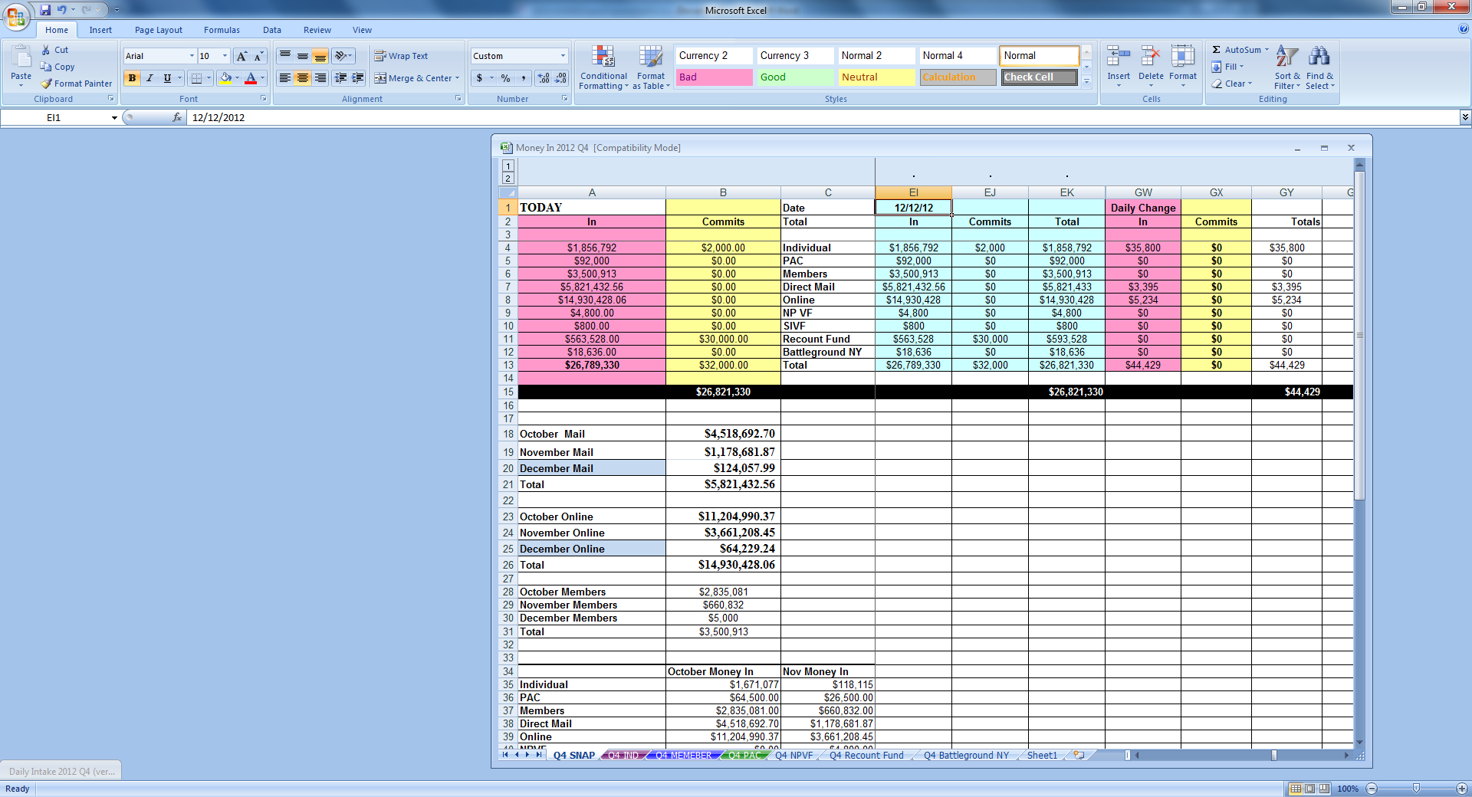

- At the bottom of the SNAP email, transfer daily change numbers.

- Next, complete today’s SNAP! You will hide all past SNAPS and create today’s SNAP beside the previous one. Use today’s date and copy and ‘PASTE SPECIAL/VALUES’ contents into the snap.

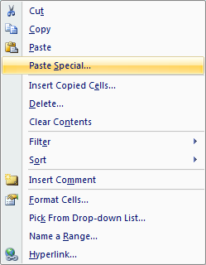

- Now, transfer today’s SNAP onto the email you are sending out and copy the chart showing all totals on the Money IN spreadsheet.
 | July Money In | August Money In | September Money In | Total
Individual | $244,500 | $0.00 | $0 | $244,500
PAC | $15,000 | $0.00 | $0 | $15,000
Members | $46,224 | $0.00 | $0 | $46,224
Direct Mail | $194,185 | $0.00 | $0 | $194,185
Online | $55,600 | $0.00 | $0 | $55,600
NPVF | $0 | $0.00 | $0 | $0
SIVF | $0 | $0.00 | $0 | $0
JPMF | $0 | $0.00 | $0 | $0
NAVF | $0 | $0.00 | $0 | $0
HSVF | $0 | $0.00 | $0 | $0
Recount Fund | $0 | $0.00 | $0 | $0
Battleground NY | $0 | $0.00 | $0 | $0
Total | $555,509 | $0 | $0 | $555,509

- You are ready to send out the SNAP!- your SNAP should look like this:
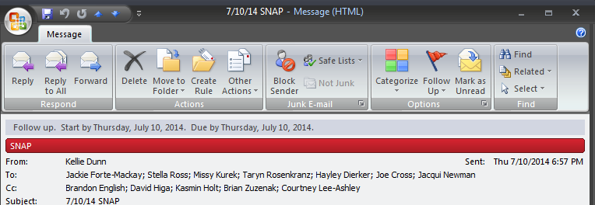
Date | 7/9/13
Total | In | Commits | Total
Individual | $244,500 | $63,500 | $308,000
PAC | $15,000 | $27,500 | $42,500
Members | $46,224 | $164,077 | $210,301
Direct Mail | $194,185 | $0 | $194,185
Online | $55,600 | $0 | $55,600
NP VF | $0 | $0 | $0
SIVF | $0 | $0 | $0
JPMF | $0 | $0 | $0
NAVF | $0 | $0 | $0
HSVF | $0 | $0
Recount Fund | $0 | $0 | $0
Battleground NY | $0 | $0 | $0
Total | $555,509 | $255,077 | $810,586
 |  |  | $810,586

 | July Money In | August Money In | September  Money In | Total
Individual | $244,500 | $0.00 | $0 | $244,500
PAC | $15,000 | $0.00 | $0 | $15,000
Members | $46,224 | $0.00 | $0 | $46,224
Direct Mail | $194,185 | $0.00 | $0 | $194,185
Online | $55,600 | $0.00 | $0 | $55,600
NPVF | $0 | $0.00 | $0 | $0
SIVF | $0 | $0.00 | $0 | $0
JPMF | $0 | $0.00 | $0 | $0
NAVF | $0 | $0.00 | $0 | $0
HSVF | $0 | $0.00 | $0 | $0
Recount Fund | $0 | $0.00 | $0 | $0
Battleground NY | $0 | $0.00 | $0 | $0
Total | $555,509 | $0 | $0 | $555,509

Vs.
Date | 7/9/12
Total | In | Commits | Total
Individual | $54,000 | $46,000 | $100,000
PAC | $15,000 | $20,000 | $35,000
Members | $40,313 | $464,211 | $504,524
Direct Mail | $307,885 | $0 | $307,885
Online | $316,316 | $0 | $316,316
NP VF | $0 | $7,750 | $7,750
JKVF
OHVF
JPMF
Battleground NY
Recount Fund 2012
Total | $733,514 | $537,961 | $1,271,475
 |  |  | $0
 |  |  | $1,271,475

Vs.
Date | 7/14/11
Total | In | Commits | Total
Individual | $220,328 | $121,150 | $341,478
PAC | $34,500 | $32,500 | $67,000
Members | $111,513 | $194,255 | $305,768
Direct Mail | $202,374 | $0 | $202,374
Online | $138,787 | $0 | $138,787
NP VF | $0 | $0 | $0
Obama Prospect Mailing | $1,850 | $0 | $0
House Senate Victory Fund | $0 | $0 | $0
Jared Polis MF | $0 | $0 | $0
DeGette Victory Fund
Total | $709,352 | $347,905 | $1,057,257
 |  |  | $1,057,257

Daily Intake: Increased by $810,586

Individual Money In: Increased by $244,500
Individual Commits: Increased by $63,500

PAC Money In: Increased by $15,000
PAC Commits: Increased by $27,500

Member Money In: Increased by $46,224
Member Commits: Increased by $164,077

Direct Mail: Increased by $194,185
Online: Increased by $55,600

Nancy Pelosi Victory Fund Money In: Increased by $0
Nancy Pelosi Victory Fund Hard Commits: Increased by $0

Steve Israel Victory Fund Money In: Increased by: $0
Steve Israel Victory Fund Hard Commits: Increased by: $0

Jared Polis Majority Fund Money In: Increased by: $0
Jared Polis Majority Fund Hard Commits: Increased by: $0

New American Victory Fund Money In: Increased by: $0
New American Victory Fund Hard Commits: Increased by: $0

House Senate Victory Fund Money In: Increased by: $0
House Senate Victory Fund Hard Commits: Increased by: $0

Recount Fund Money In: Increased by $0
Recount Fund Hard Commits: Increased by $0

