Hon. Thomas D'Alesandro & Margaret D'Alesandro
6646 Walnutwood Circle

Baltimore, MD 21212-1213

Dear Margie & Tommy,

Thank you so much for your generous contribution to the Democratic Congressional Campaign Committee. Your support is critical as we prepare for the 2014 elections.

House Democrats are working for a positive agenda for the American people, but this Republican Congress continues to block progress on issue after issue—from gun violence prevention to immigration reform—and continues to put middle class families last. The only way we can advance our priorities is to elect more Democrats to the House next year.

And because of your support, we are already hard at work for 2014. We are working with incumbents to ensure that their campaigns are prepared from Day One, and we are having early success recruiting strong, problem-solving candidates in districts across the country.

Americans will have a choice next November—between the chaos and extreme ideology of this Republican Congress, and the forward-looking agenda of House Democrats that stands up for the middle class. With your help, we will make that choice clear for voters, and I am confident they will stand with us.

Thank you for your support as we work together toward the Majority.

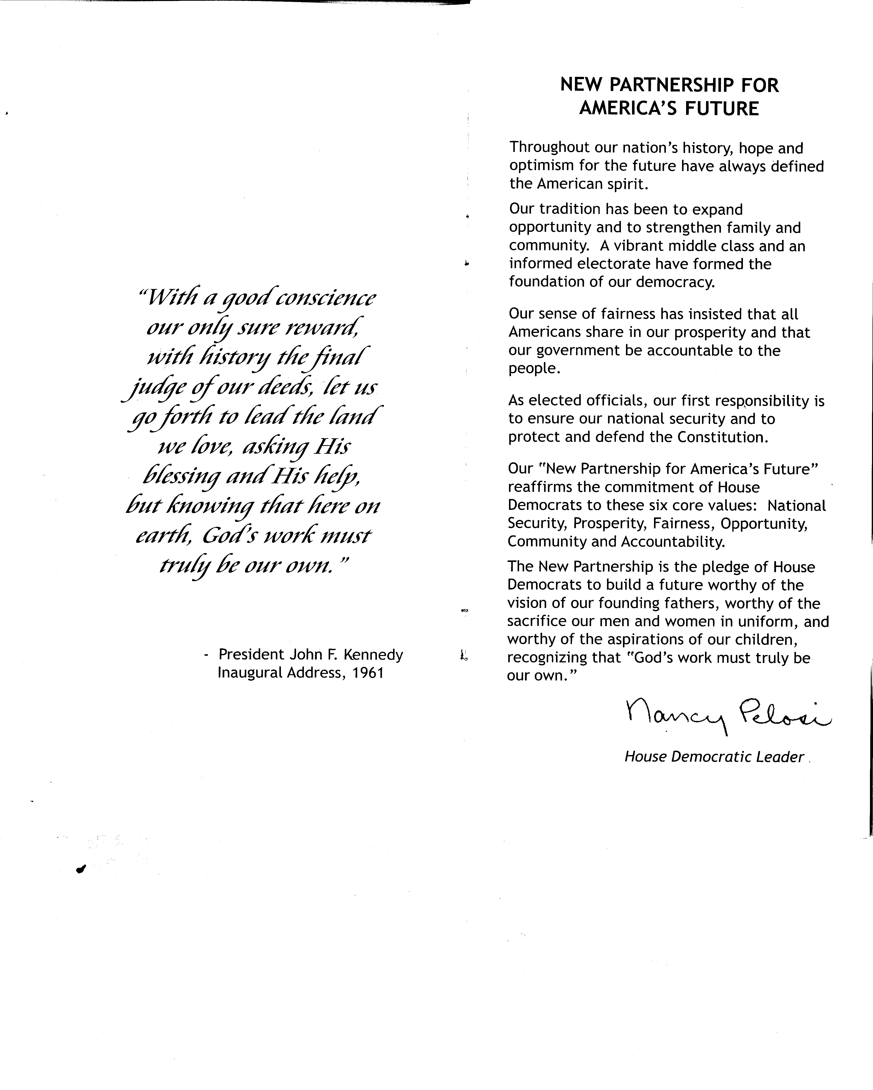
Best regards,

Nancy Pelosi

