DCCC Political Memo

To: Leader Pelosi

From: Kelly Ward

Date: June 9, 2014

Subject: Meeting with Sens. Reid & Bennet & Leader Pelosi re: Senate/House Coordination

Meeting Overview:

Purpose: This meeting came from a conversation between YOU and Sen. Reid. You requested this

meeting to discuss how the Senate and House can best coordinate on the ground in our overlapping states.

Attendees: Sen. Reid, Sen. Bennet, YOU, Chairman Israel, Guy Cecil, Kelly Ward

Talking Points:

- Please let Senators Reid and Bennet know that we are very pleased with the levels of coordination in our overlapping states. We have been working closely with the DSCC on building coordinated campaigns, identifying shared targets, and partnering in the areas where our programs overlap.

- While coordination is always a work in process, we have a great working relationship thus far and expect that to continue.

- As the cycle goes on, additional opportunities for coordination include:
  - Partnering on Vote By Mail programs
  - Generic GOTV efforts to dropoff voters
  - Sharing data and models (eg polling, voter contact models, etc)

- Please ask what non-money requests the Senate has made of POTUS. Do they want him to travel? Where do they want him to go and when? What other ways do they want him and the First Lady to help?

State-By-State Background:

The House and Senate targets overlap in five states: Arkansas, Colorado, Iowa, Michigan and New Hampshire. If Virginia and Georgia become more real for them and Kentucky becomes more real for us, those three states could also be added to the shared list at some point.

A Note On Process: The DSCC runs the Coordinated Campaigns in their targeted states. The DCCC does not do “buy ins” into Coordinated Campaigns; meaning we do not give lump sums of money to pay a portion of the Coordinated Campaign budget. Instead, we work with Coordinated Campaigns state-by-state to ensure our investment covers the specific programmatic elements that are needed to win in our targeted districts.

Below is a summary of how we are working with the DSCC and Coordinated Campaigns in each of our overlapping states. An update on NV-03 is also included given Senator Reid’s personal interest in this district.

Arkansas
DCCC Targets:
AR-01 – Jackie McPherson (Emerging)
AR-02 – Patrick Henry Hayes (Red to Blue)
AR-04 – James Lee Witt (Red to Blue)

Program Summary:
The DCCC is working with the Arkansas Coordinated Campaign to ensure the statewide efforts currently underway for Sen. Mark Pryor are leveraged toward our pick-up opportunities in AR-02 (Red to Blue), AR-04 (Red to Blue) and AR-01 (Emerging). We are currently in negotiations with them about the programmatic focus in each district (registration vs. persuasion vs. turnout), a reporting and accountability structure, and a process for the DCCC investment that can be adjusted based on district-specific performance and competitiveness. Once we finalize an agreement, our investment will add additional staff to the current statewide staff plan.

Colorado
DCCC Target:
CO-06 – Andrew Romanoff (Red to Blue)

Program Summary:
The DCCC is working with the Coordinated Campaign in Colorado on an agreement to take over the operations in CO-06. The 6th district is a key swing district statewide, and a top pick-up opportunity for DCCC. Our staff allocation in CO-06 is 11 staffers larger than the initial coordinated plan, so our investment will add to the overall coordinated program in CO-06. We hope to come to an agreement on the target universe and reporting structure early this week.

Iowa
DCCC Targets:
IA-01 – Pat Murphy (Red to Blue)
IA-03 – Staci Appel (Red to Blue)

Program Summary:
Iowa has a long tradition of running a robust Coordinated Campaign. We are negotiating with the Iowa State Party to cover the Coordinated Campaign costs for Staci Appel in IA-03 and Pat Murphy in IA-01. We are currently coming to an agreement on the Coordinated Campaign’s structure and plan and are close to finalizing the program here.

Michigan
DCCC Targets:

MI-01 – Jerry Cannon (Red to Blue)

MI-07 – Pam Byrnes (Red to Blue)

MI-11 – Democratic Primary (Emerging District)

Program Summary:
The Michigan Coordinated Campaign is focused largely outside of our targeted districts; however, they are considering building a statewide Vote By Mail program, which could benefit our candidates. At this time, we are operating outside the structure of the Coordinated Campaign with direct investments in a MI-07 field program. If a statewide VBM program develops, MI-07 will be included. All parties are satisfied with this structure, and the Coordinated Campaign is not asking the DCCC or our campaigns for “buy-in” money.

New Hampshire
DCCC Targets:
NH-01 – Rep. Shea-Porter (Frontline)
NH-02 – Rep. Annie Kuster (Frontline)

Program Summary:
Conversations with the NH Coordinated Campaign are in the very early stages. The DSCC has not yet invested in a large way in this state and we are waiting on a written plan from the Coordinated Campaign to start the conversation about a potential partnership. Meanwhile, the DCCC is investing in large field programs in both NH-01 and NH-02.

Nevada
DCCC Target:
NV-03 – Erin Bilbray (Red to Blue)

Program Summary:
We have had several conversations with the Nevada State Party about potential coordination and recently received the full Coordinated Campaign plan. We are currently investing in a small field program in NV-03 and discussing the potential for future investments with the Coordinated Campaign.
AR-01 DISTRICT SUMMARY
FINANCIAL INFO
2014 Q1 Candidate Summary
Name | Party | Q1 Raised | Q1 Spent | Q1 COH | Cycle Raised
Rick Crawford | R | $97,455.00 | $70,556.00 | $360,524.00 | $529,353.00
Jackie McPherson | D | $111,645.00 | $10,962.00 | $100,682.00 | $111,645.00

2012 Candidate Cycle Summary
Name | Party | Cycle Raised | Cycle Spent | Ending COH
Scott Ellington | D | $372,375 | $370,676 | $1,698
Rick Crawford | R | $1,339,445 | $1,274,636 | $155,981

2012 Major Democratic v. Republican IE Spending
Name | Party | IE
DCCC | D | $0
House Majority PAC | D | $0
Other Democratic Spending | D | $15,452.26
NRCC | R | $0
Other Republican Spending | R | $418.50
All Democratic Spending |  | $15,452.26
All Republican Spending |  | $418.50
 |  |  |  | $15,870.76
2012 DCCC Full Itemized Spending
Name | Field | IE | Other Spending | Total
DCCC | $41,390.00 | $0 | $24,086.23 | $65,476.23

DISTRICT DATA
DPI 49.6%
AfAm 17.7%
Hispanic 2.8%
Other 2.0%
Total Minority 22.6%

MAJOR CITIES
Jonesboro
Little Rock Suburbs

MEDIA MARKETS
Little Rock-Pinebluff (38%)
$180 (Politics) / $240 (Issue)

Jonesboro (27%)
$55 (Politics) / $88 (Issue)

Memphis (26%)
$150 (Politics) / $215 (Issue)

Springfield, MO (9%)
$104 (Politics) / $149 (Issue)

Greenwood-Greenville (0%)
$35 (Politics) / $50 (Issue)

2012 PAID COMMUNICATIONS THEMES
- N/A

ELECTION RESULTS
Congressional Statistics
(2 Party Only)
Cycle | W/L | Candidate | Party | Vote
2012 | L | ELLINGTON | DEM | 41.0%
2012 | W | CRAWFORD | REP | 59.0%
2010 | L | (redistricting) | DEM | 47.2%
2010 | W | (redistricting) | REP | 52.8%
2008 | W | (redistricting) | DEM | 91.4%
2008 | L | (redistricting) | REP | 8.6%

Presidential Statistics
(2 Party Only)
Cycle | Candidate | Party | Vote
2012 | OBAMA | DEM | 37.3%
2012 | ROMNEY | REP | 62.7%
2008 | OBAMA | DEM | 40.2%
2008 | McCAIN | REP | 59.1%

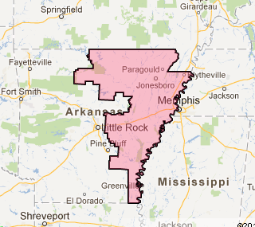

AR-02 DISTRICT SUMMARY
FINANCIAL INFO
2014 Q1 Candidate Summary
Name | Party |  | Q1 Raised | Q1 Spent | Q1COH | Cycle Raised
Patrick Henry-Hays | D | $353,887.00 |  | $93,004.00 | $470,607.00 | $584,984.00
James French Hill | R | $300,133.00 |  | $116,674.00 | $714,434.00 | $870,247.00

2012 Candidate Cycle Summary
Name | Party | Cycle Raised | Cycle Spent | Ending COH
Herb Rule | D | $251,060 | $238,701 | $12,358
Tim Griffin | R | $1,619,346 | $1,659,463 | $41,371

2012 Major Democratic v. Republican IE Spending
Name | Party | IE
DCCC | D | $0
House Majority PAC | D | $60,173.64
Other Democratic Spending | D | $0
NRCC | R | $0
Other Republican Spending | R | $0
All Democratic Spending |  | $60,173.64
All Republican Spending |  | $0
 |  |  |  | $60,173.64
2012 DCCC Full Itemized Spending
Name | Field | IE | Other Spending | Total
DCCC | $0 | $0 | $0 | $0

ELECTION RESULTS
Congressional Statistics
(2 Party Only)
Cycle | W/L | Candidate | Party | Vote
2012 | L | RULE | DEM | 41.7%
2012 | W | GRIFFIN | REP | 58.3%
2010 | L | (redistricting) | DEM | 40.2%
2010 | W | (redistricting) | REP | 59.8%
2008 | W | (redistricting) | DEM | 76.4%
2008 | L | (redistricting) | REP | 23.6%

Presidential Statistics
(2 Party Only)
Cycle | Candidate | Party | Vote
2012 | OBAMA | DEM | 43.9%
2012 | ROMNEY | REP | 56.1%
2008 | OBAMA | DEM | 45.3%
2008 | McCAIN | REP | 54.7%

MEDIA MARKETS
Little Rock-Pine Bluff (100%)
$180 (Politics) / $240 (Issue)

DISTRICT DATA
DPI 50.8%
AfAm 21.3%
Hispanic 4.8%
Other 3.5%
Total Minority 29.6%

MAJOR CITIES
Little Rock

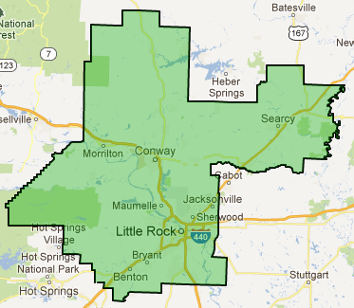

2012 PAID COMMUNICATIONS THEMES
- N/A

AR-04 DISTRICT SUMMARY

FINANCIAL INFO
2014 Q1 Candidate Summary
Name | Party | Q1 Raised | Q1 Spent | Q1 COH | Cycle Raised
James Lee Witt | D | $268,802.00 | $119,173.00 | $316,022.00 | $512,748.00
Bruce Westerman | R | $65,125.00 | $83,910.00 | $136,207.00 | $282,666.00

2012 Candidate Cycle Summary
Name | Party | Cycle Raised | Cycle Spent | Ending COH
Gene Jeffress | D | $100,330 | $98,039 | $322
Thomas Cotton | R | $2,213,217 | $2,094,866 | $118,350

2012 Major Democratic v. Republican IE Spending
Name | Party | IE
DCCC | D | $0
House Majority PAC | D | $0
Other Democratic Spending | D | $0
NRCC | R | $0
Other Republican Spending | R | $10,812.54
All Democratic Spending |  | $0
All Republican Spending |  | $10,812.54
 |  |  |  | $10,812.54
2012 DCCC Full Itemized Spending
Name | Field | IE | Other Spending | Total
DCCC | $0 | $0 | $0 | $0

DISTRICT DATA
DPI 46.4%
AfAm 19.5%
Hispanic 5.4%
Other 2.8%
Total Minority 27.7%

MAJOR CITIES
Pine Bluff
El Dorado
MEDIA MARKETS
Little Rock-Pine Bluff (56%)
$180 (Politics) / $240 (Issue)

Shreveport (18%)
$117 (Politics) / $171 (Issue)

Ft. Smith-Fay-Springdale-Rgrs (16%)
$90 (Politics) / $117 (Issue)

Monroe-El Dorado (9%)
$45 (Politics) / $57 (Issue)

Springfield, MO (0%)
$112 (Politics) / $160 (Issue)

ELECTION RESULTS
Congressional Statistics
(2 Party Only)
Cycle | W/L | Candidate | Party | Vote
2012 | L | JEFFRESS | DEM | 38.1%
2012 | W | COTTON | REP | 61.9%
2010 | W | (redistricting) | DEM | 53.6%
2010 | L | (redistricting) | REP | 46.4%
2008 | W | (redistricting) | DEM | 83.4%
2008 | L | (redistricting) | GREEN | 16.6%

Presidential Statistics
(2 Party Only)
Cycle | Candidate | Party | Vote
2012 | OBAMA | DEM | 36.7%
2012 | ROMNEY | REP | 63.3%
2008 | OBAMA | DEM | 38.2%
2008 | McCAIN | REP | 61.8%

2012 PAID COMMUNICATIONS THEMES
- N/A

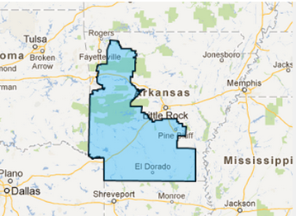

CO-06 DISTRICT SUMMARY
FINANCIAL INFO
2014 Q1 Candidate Summary
Name | Party | Q1 Raised | Q1 Spent | Q1 COH | Cycle Raised
Andrew Romanoff | D | $603,520.00 | $174,519.00 | $2,098,619.00 | $2,607,982.00
Mike Coffman | R | $593,805.00 | $226,699.00 | $1,844,742.00 | $2,608,312.79

2012 Candidate Cycle Summary
Name | Party | Cycle Raised | Cycle Spent | Ending COH
Joe Miklosi | D | $1,709,751 | $1,694,977 | $12,272
Mike Coffman | R | $3,240,967 | $3,233,134 | $7,832

2012 Major Democratic v. Republican IE Spending
Name | Party | IE
DCCC | D | $2,056,633.21
House Majority PAC | D | $962,844.28
Other Democratic Spending | D | $898,702.35
NRCC | R | $2,136,089.02
Other Republican Spending | R | $281,265.38
All Democratic Spending |  | $3,918,179.84
All Republican Spending |  | $2,417,354.40
 |  |  |  | $6,335,534.24
2012 DCCC Full Itemized Spending
Name | Field | IE | Other Spending | Total
DCCC | $157,015 | $2,056,633 | $483,430 | $2,936,313

ELECTION RESULTS
Congressional Statistics
(2 Party Only)
Cycle | W/L | Candidate | Party | Vote
2012 | L | MIKLOSI | DEM | 48.9%
2012 | W | COFFMAN | REP | 51.1%
2010 | L | (redistricting) | DEM | 41.8%
2010 | W | (redistricting) | REP | 58.2%
2008 | L | (redistricting) | DEM | 49.8%
2008 | W | (redistricting) | REP | 50.2%

Presidential Statistics
(2 Party Only)
Cycle | Candidate | Party | Vote
2012 | OBAMA | DEM | 52.8%
2012 | ROMNEY | REP | 47.2%
2008 | OBAMA | DEM | 54.4%
2008 | McCAIN | REP | 45.6%

DISTRICT DATA
DPI 49.1%
AfAm 8.4%
Hispanic 16.7%
Other 8.9%
Total Minority 34.0%

MAJOR CITIES
Aurora
MEDIA MARKETS
Denver (100%)
$352 (Politics) / $565 (Issue)

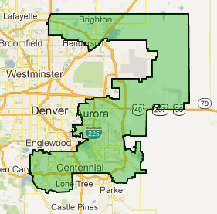

2012 PAID COMMUNICATIONS THEMES
- Miklosi and allies ran spots attempting to identify him with average voters in the district – while connecting Coffman to Rush Limbaugh and highlighting him as out of touch.
- Coffman and allies ran spots about Coffman as a fighter for the middle class. They ran spots connecting Miklosi to bad votes on justice for sex offenders and child predators.

IA-01 DISTRICT SUMMARY
FINANCIAL INFO
2014 Q1 Candidate Summary
Name | Party | Q1 Raised | Q1 Spent | Q1 COH | Cycle Raised
Patrick Murphy | D | $100,257.00 | $32,041.00 | $232,504.00 | $433,679.00
Rodney Blum | R | $77,710.00 | $42,000.00 | $210,767.00 | $302,731.00

2012 Candidate Cycle Summary
Name | Party | Cycle Raised | Cycle Spent | Ending COH
Bruce Braley | D | $2,687,000 | $2,664,440 | $51,462
Ben Lange | R | $1,079,677 | $1,075,866 | $3,810

2012 Major Democratic v. Republican IE Spending
Name | Party | IE
DCCC | D | $0
House Majority PAC |  | $136,720.77
Other Democratic Spending |  | $391,419.57
NRCC | R | $416,014.45
Other Republican Spending |  | $56,600.87
All Democratic Spending |  | $528,140.34
All Republican Spending |  | $567,728.40
 |  |  |  | $1,095,868.74
2012 DCCC Full Itemized Spending
Name | Field | IE | Other Spending | Total
DCCC | $0.00 | $0.00 | $7.97 | $7.97

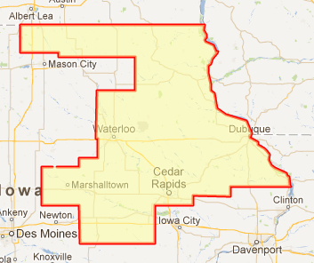
2012 PAID COMMUNICATIONS THEMES
- N/A
ELECTION RESULTS
Congressional Statistics
(2 Party Only)
Cycle | W/L | Candidate | Party | Vote
2012 | W | BRALEY | DEM | 57.8%
2012 | L | LANGE | REP | 42.2%
2010 | L | (redistricting) | DEM | 49.7%
2010 | W | (redistricting) | REP | 50.3%
2008 | W | (redistricting) | DEM | 60.8%
2008 | L | (redistricting) | REP | 39.2%

Presidential Statistics
(2 Party Only)
Cycle | Candidate | Party | Vote
2012 | OBAMA | DEM | 56.9%
2012 | ROMNEY | REP | 43.1%
2008 | OBAMA | DEM | 59.1%
2008 | MCCAIN | REP | 40.9%

DISTRICT DATA
DPI 54.7%
AfAm 2.8%
Hispanic 2.5%
Other 3.0%
Total Minority 8.3%

MAJOR CITIES
Cedar Rapids

MEDIA MARKETS
Cedar Rapids-Wtrlo-IWC & Dub (86%)
$65 (Politics) / $125 (Issue)

Des Moines-Ames (8%)
$95 (Politics) / $210 (Issue)

Rochester-Mason City-Austin (4%)
$63 (Politics)/ $90 (Issue)

Davenport-R.Island-Moline (3%)
$140 (Politics) / $215 (Issue)

IA-03 DISTRICT SUMMARY
FINANCIAL INFO
2014 Q1 Candidate Summary
Name | Party | Q1 Raised | Q1 Spent | Q1 COH | Cycle Raised
Staci Appel | D | $263,591.00 | $162,665.00 | $470,416.00 | $763,173.00
Dave Young | R | $78,081.00 | $78,971.00 | $132,845.00 | $476,162.00
Matt Schultz | R | $170,949.00 | $34,304.00 | $136,645.00 | $170,949.00
Monte Shaw | R | $203,937.00 | $35,491.00 | $168,445.00 | $203,937.00
Robert Cramer | R | $212,653.00 | $133,916.00 | $78,736.00 | $212,653.00
Brad Zaun | R | $56,746.00 | $10,203.00 | $46,542.00 | $56,746.00

2012 Candidate Cycle Summary
Name | Party | Cycle Raised | Cycle Spent | Ending COH
Leonard Boswell | D | $1,747,775 | $1,766,438 | $46,612
Tom Latham | R | $3,412,780 | $3,886,262 | $117,560

2012 Major Democratic v. Republican IE Spending
Name | Party | IE
DCCC | D | $1,481,231.39
House Majority PAC | D | $496,134.21
Other Democratic Spending | D | $121,094.65
NRCC | R | $444,899.03
Other Republican Spending | R | $2,806,799.72
All Democratic Spending (Includes spending under $50,000) |  | $2,098,460.25
All Republican Spending (Includes spending under $50,000) |  | $3,251,698.75
 |  |  |  | $5,350,159.00
2012 DCCC Full Itemized Spending
Name | Field | IE | Other Spending | Total
DCCC | $161,757.00 | $1,481,231.39 | $154,501.20 | $1,797,489.59

ELECTION RESULTS
Congressional Statistics
(2 Party Only)
Cycle | W/L | Candidate | Party | Vote
2012 | L | BOSWELL | DEM | 45.5%
2012 | W | LATHAM | REP | 54.5%
2010 | L | (redistricting) | DEM | 45.6%
2010 | W | (redistricting) | REP | 54.4%
2008 | W | (redistricting) | DEM | 50.5%
2008 | L | (redistricting) | REP | 49.5%

Presidential Statistics
(2 Party Only)
Cycle | Candidate | Party | Vote
2012 | OBAMA | DEM | 52.2%
2012 | ROMNEY | REP | 47.8%
2008 | OBAMA | DEM | 53.1%
2008 | MCCAIN | REP | 46.9%

MEDIA MARKETS
Des Moines (79%)
$95 (Politics) / $210 (Issue)

Omaha, NE (21%)
$92 (Politics) / $135 (Issue)

DISTRICT DATA
DPI 50.7%
AfAm 3.3%
Hispanic: 4.7%
Other: 4.3%
Total Minority: 12.3%

MAJOR CITIES
Des Moines
Council Bluffs

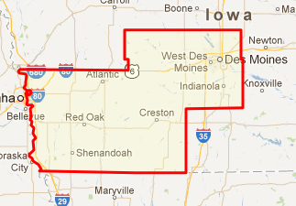

2012 PAID COMMUNICATIONS THEMES
- Boswell ran spots about the Latham family bank and their personal gain from TARP.
- Democratic allies ran argued that Latham wasn’t looking out for middle class Iowans citing Medicare, Social Security and bad trade deals.
- Latham and his allies ran positive spots about Latham’s personal history growing up on a seed farm. They turned their attention Boswell as a long time politician.
MI-01 DISTRICT SUMMARY
FINANCIAL INFO
2014 Q1 Candidate Summary
Name | Party |  | Q1 Raised | Q1 Spent | Q1 COH | Cycle Raised
Jerry Cannon |  | D | $145,670.00 | $70,124.00 | $270,479.00 | $438,303.00
Dan Benishek |  | R | $145,417.00 | $66,766.00 | $654,483.00 | $980,086.00

2012 Candidate Cycle Summary
Name | Party | Cycle Raised | Cycle Spent | Ending COH
Gary McDowell | D | $1,497,727 | $1,488,710 | $9,065
Dan Benishek | R | $2,224,860 | $2,171,929 | $88,651

2012 Major Democratic v. Republican IE Spending
Name | Party | IE
DCCC | D | $731,418.54
House Majority PAC | D | $511,639.92
Other Democratic Spending | D | $2,361,457.57
NRCC | R | $1,622,619.42
Other Republican Spending | R | $1,174,180.06
All Democratic Spending |  | $3,604,516.03
All Republican Spending |  | $2,796,799.48
 |  |  |  | $6,510,769.88
2012 DCCC Full Itemized Spending
Name | Field | IE | Other Spending | Total
DCCC | $153,195.00 | $731,418.54 | $191,515.98 | $1,076,129.52

ELECTION RESULTS
Congressional Statistics
(2 Party Only)
Cycle | W/L | Candidate | Party | Vote
2012 | L | MCDOWELL | DEM | 49.7%
2012 | W | BENISHEK | REP | 50.3%
2010 | L | (redistricting) | DEM | 41.4%
2010 | W | (redistricting) | REP | 58.6%
2008 | W | (redistricting) | DEM | 58.5%
2008 | L | (redistricting) | REP | 41.5%

Presidential Statistics
(2 Party Only)
Cycle | Candidate | Party | Vote
2012 | OBAMA | DEM | 45.8%
2012 | ROMNEY | REP | 54.2%
2008 | OBAMA | DEM | 50.6%
2008 | McCAIN | REP | 49.4%

MEDIA MARKETS
Traverse City-Cadillac (59%)
$65 (Politics) / $94 (Issue)

Marquette (29%)
$40 (Politics) / $57 (Issue)

Alpena (6%)
$30 (Politics) / $43 (Issue)

Green Bay-Appleton (3%)
$85 (Politics) / $116 (Issue)

Duluth-Superior (2%)
$56 (Politics) / $80 (Issue)

DISTRICT DATA
DPI 46.8%
AfAm 1.5%
Hispanic 1.1%
Other 5.3%
Total Minority 7.9%

MAJOR CITIES
Traverse City
Marquette
Sault Ste. Marie
Alpena
2012 PAID COMMUNICATIONS THEMES
- McDowell and allies came out early to define Gary as not a typical politician – then attacked Benishek for the Ryan Budget and environmental issues – including Canadian Trash and the Clean Water Act.
- Benishek and allies hit hard early on Medicare – relying on tracking footage of Gary saying “we are taking so much money for healthcare at the end of life.” They closed by tying Gary to Jennifer Granholm and legislative tax hikes from his time in Lansing.

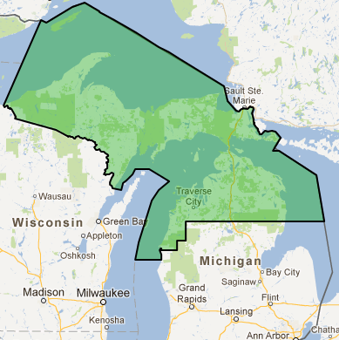

MI-07 DISTRICT SUMMARY
FINANCIAL INFO
2014 Q1 Candidate Summary
Name | Party | Q1 Raised | Q1 Spent | Q1 COH | Cycle Raised
Pam Byrnes | D | $221,833.00 | $97,950.00 | $423,342.00 | $613,946.00
Tim Walberg | R | $189,403.00 | $826,648.00 | $836,670.00 | $904,440.00

2012 Candidate Cycle Summary
Name | Party | Cycle Raised | Cycle Spent | Ending COH
Kurt Haskell | D | $101,141 | $101,252 | $0
Tim Walberg | R | $1,533,549 | $1,309,734 | $276,102

2012 Major Democratic v. Republican IE Spending
Name | Party | IE
DCCC | D | $0
House Majority PAC | D | $0
Other Democratic Spending | D | $0
NRCC | R | $0
Other Republican Spending | R | $546.02
All Democratic Spending |  | $0
All Republican Spending |  | $546.02
 |  |  |  | $546.02
2012 DCCC Full Itemized Spending
Name | Field | IE | Other Spending | Total
DCCC | $0 | $0 | $0 | $0

MEDIA MARKETS
Lansing (44%)
$96 (Politics) / $138 (Issue)

Detroit, MI (36%)
$325 (Politics) / $405 (Issue)

Toledo, OH (14%)
$131 (Politics) / $189 (Issue)

Grand Rapids-Kalmzoo (6%)
$170 (Politics) / $254 (Issue)

DISTRICT DATA
DPI 46.9%
AfAm 4.0%
Hispanic 3.1%
Other 3.3%
Total Minority 10.4%

MAJOR CITIES
Jackson
Monroe

ELECTION RESULTS
Congressional Statistics
(2 Party Only)
Cycle | W/L | Candidate | Party | Vote
2012 | L | HASKELL | DEM | 44.6%
2012 | W | WALBERG | REP | 55.4%
2010 | L | (redistricting) | DEM | 45.1%
2010 | W | (redistricting) | REP | 54.9%
2008 | W | (redistricting) | DEM | 52.1%
2008 | L | (redistricting) | REP | 47.9%

Presidential Statistics
(2 Party Only)
Cycle | Candidate | Party | Vote
2012 | OBAMA | DEM | 48.4%
2012 | ROMNEY | REP | 51.6%
2008 | OBAMA | DEM | 51.7%
2008 | McCAIN | REP | 48.3%

2012 PAID COMMUNICATIONS THEMES
- There was not a competitive race in this district in 2012

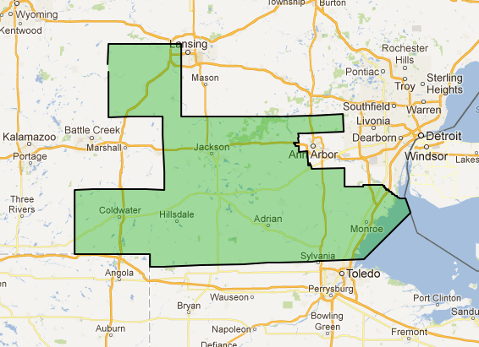

MI-11 DISTRICT SUMMARY
FINANCIAL INFO
2014 Q1 Candidate Summary
Name | Party | Q1 Raised | Q1 Spent | Q1 COH | Cycle Raised
Nancy Skinner | D | N/A | N/A | N/A | N/A
Anil Kumar | D | $307,844.00 | $174,074.00 | $610,541.00 | $626,624.00
Kerry Bentivolio | R | $110,731.00 | $90,180.00 | $129,499.00 | $403,655.00
David Trott | R | $587,335.00 | $256,543.00 | $1,041,521.00 | $1,686,419.00

2012 Candidate Cycle Summary
Name | Party | Cycle Raised | Cycle Spent | Ending COH
Syed Taj | D | $705,593 | $698,355 | $7,238
Kerry Bentivolio | R | $588,811 | $585,301 | $3,509

2012 Major Democratic v. Republican IE Spending
Name | Party | IE
DCCC | D | $0
House Majority PAC | D | $0
Other Democratic Spending | D | $310,010.51
NRCC | R | $0
Other Republican Spending | R | $873,182.18
All Democratic Spending |  | $310,010.51
All Republican Spending |  | $873,182.18
 |  |  |  | $1,183,192.69

2012 DCCC Full Itemized Spending
Name | Field | IE | Other Spending | Total
DCCC | $0.00 | $0.00 | $10,000.00 | $10,000.00

DISTRICT DATA
DPI 44.3%
AfAm 4.7%
Hispanic 2.6%
Other 9.5%
Total Minority 16.8%

MAJOR CITIES
Troy
Livonia

ELECTION RESULTS
Congressional Statistics
(2 Party Only)
Cycle | W/L | Candidate | Party | Vote
2012 | L | TAJ | DEM | 46.6%
2012 | W | BENTIVOLIO | REP | 53.4%
2010 | L | (redistricting) | DEM | 38.5%
2010 | W | (redistricting) | REP | 61.5%
2008 | L | (redistricting) | DEM | 45.4%
2008 | W | (redistricting) | REP | 54.6%

Presidential Statistics
(2 Party Only)
Cycle | Candidate | Party | Vote
2012 | OBAMA | DEM | 47.3%
2012 | ROMNEY | REP | 52.7%
2008 | OBAMA | DEM | 51.0%
2008 | McCAIN | REP | 49.0%

MEDIA MARKETS
Detroit (100%)
$325 (Politics) / $405 (Issue)

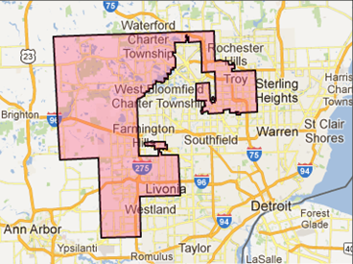

2012 PAID COMMUNICATIONS THEMES
- This race was not heavily contested in the general election but there was significant spending in the Republican primary and in a special election that occurred on the same day.

NH-01 DISTRICT SUMMARY
FINANCIAL INFO
2014 Q1 Candidate Summary
Name | Party | Q1 Raised | Q1 Spent | Q1 COH | Cycle Raised
Carol Shea-Porter | D | $199,935.00 | $44,826.00 | $513,897.00 | $735,911.00
Frank Guinta | R | $154,506.00 | $62,741.00 | $219,907.00 | $326,009.00
Daniel Innis | R | $61,442.00 | $35,813.00 | $56,669.00 | $167,837.00

2012 Candidate Cycle Summary
Name | Party | Cycle Raised | Cycle Spent | Ending COH
Carol Shea-Porter | D | $1,720,667 | $1,696,702 | $24,944
Frank Guinta | R | $1,903,770 | $1,869,673 | $34,444

2012 Major Democratic v. Republican IE Spending
Name | Party | IE
DCCC | D | $1,989,559.24
House Majority PAC | D | $113,994.64
Other Democratic Spending | D | $221,926.53
NRCC | R | $338,233.32
Other Republican Spending | R | $2,281,196.08
All Democratic Spending |  | $2,325,480.41
All Republican Spending |  | $2,619,429.40
 |  |  |  | $4,944,909.81
2012 DCCC Full Itemized Spending
Name | Field | IE | Other Spending | Total
DCCC | $49,135.00 | $1,989,559.24 | $389,955.38 | $2,428,649.62

MEDIA MARKETS
Boston (Manchester) (92%)
$660 (Politics) / $875 (Issue)

Portland-Auburn (8%)
$120 (Politics) / $180 (Issue)

DISTRICT DATA
DPI 49.4%
AfAm 0.7%
Hispanic 1.4%
Other 1.4%
Total Minority 3.5%

MAJOR CITIES
Manchester
Rochester

ELECTION RESULTS
Congressional Statistics
(2 Party Only)
Cycle | W/L | Candidate | Party | Vote
2012 | W | SHEA-PORTER | DEM | 52.0%
2012 | L | GUINTA | REP | 48.0%
2010 | L | (redistricting) | DEM | 44.1%
2010 | W | (redistricting) | REP | 55.9%
2008 | W | (redistricting) | DEM | 53.2%
2008 | L | (redistricting) | REP | 46.8%

Presidential Statistics
(2 Party Only)
Cycle | Candidate | Party | Vote
2012 | OBAMA | DEM | 50.8%
2012 | ROMNEY | REP | 49.2%
2008 | OBAMA | DEM | 53.2%
2008 | McCAIN | REP | 46.8%

2012 PAID COMMUNICATIONS THEMES
- Shea-Porter reminded voters that Guinta was named one of the most corrupt Members of Congress, spent the most on franked mail and belongs to the tea party.
- Guinta moderated himself in his ads, focusing on job creation, support for veterans and lowering taxes.

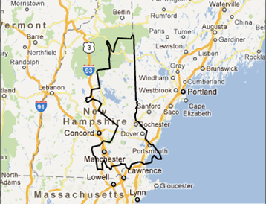

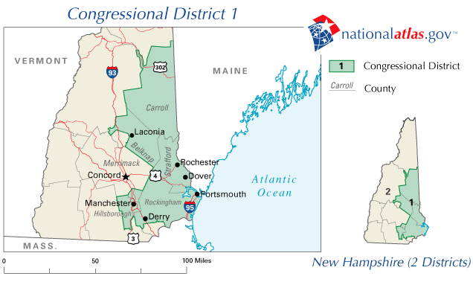
NH-02 DISTRICT SUMMARY
FINANCIAL INFO
2014 Q1 Candidate Summary
Name | Party | Q1 Raised | Q1 Spent | Q1 COH | Cycle Raised
Annie Kuster | D | $402,539.00 | $100,796.00 | $1,371,257.00 | $1,740,228.00
Gary Lambert | R | $75,767.00 | $34,494.00 | $259,814.00 | $321,176.00
Marilinda Garcia | R | $69,050.00 | $44,622.00 | $58,646.00 | $111,080.00

2012 Candidate Cycle Summary
Name | Party | Cycle Raised | Cycle Spent | Ending COH
Annie Kuster | D | $3,161,003 | $3,173,921 | $6,803
Charlie Bass | R | $2,066,087 | $2,072,140 | $25,622

2012 Major Democratic v. Republican IE Spending
Name | Party | IE
DCCC | D | $2,004,006.42
House Majority PAC | D | $576,746.39
Other Democratic Spending | D | $694,983.04
NRCC | R | $1,798,271.72
Other Republican Spending | R | $41,549.80
All Democratic Spending |  | $3,275,735.85
All Republican Spending |  | $1,839,821.52
 |  |  |  | $5,115,557.37
2012 DCCC Full Itemized Spending
Name | Field | IE | Other Spending | Total
DCCC | $87,780.00 | $2,004,006.42 | $337,094.38 | $2,428,880.80

MEDIA MARKETS
Boston (Manchester) (76%)
$660 (Politics) / $875 (Issue)

Burlington-Plattsburgh (20%)
$105 (Politics) / $145 (Issue)

Portland-Auburn (4%)
$120 (Politics) / $180 (Issue)

DISTRICT DATA
DPI 53.2%
AfAm 0.6%
Hispanic 1.4%
Other 1.6%
Total Minority 4.4%

MAJOR CITIES
Concord
Berlin
2012 PAID COMMUNICATIONS THEMES
- Republicans painted Kuster as a liberal who supports Obamacare and stimulus packages, and Bass as a pro-choice moderate who cares about women and working people.
- Democrats said Bass is anti-middle class, tight with DC lobbyists; Kuster will work together for middle class families.
ELECTION RESULTS
Congressional Statistics
(2 Party Only)
Cycle | W/L | Candidate | Party | Vote
2012 | W | KUSTER | DEM | 52.5%
2012 | L | BASS | REP | 47.5%
2010 | L | (redistricting) | DEM | 49.0%
2010 | W | (redistricting) | REP | 51.0%
2008 | W | (redistricting) | DEM | 57.5%
2008 | L | (redistricting) | REP | 42.5%

Presidential Statistics
(2 Party Only)
Cycle | Candidate | Party | Vote
2012 | OBAMA | DEM | 54.9%
2012 | ROMNEY | REP | 45.1%
2008 | OBAMA | DEM | 56.5%
2008 | McCAIN | REP | 43.5%

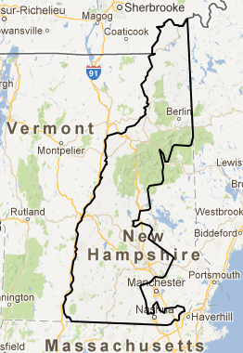

NV-03 DISTRICT SUMMARY
FINANCIAL INFO
2014 Q1 Candidate Summary
Name | Party |  | Q1 Raised | Q1 Spent | Q1 COH | Cycle Raised
Erin Bilbray | D | $271,528.00 |  | $90,533.00 | $426,518.00 | $689,348.00
Joe Heck | R | $365,086.00 |  | $146,240.00 | $1,238,995.00 | $1,482,854.00

2012 Candidate Cycle Summary
Name | Party | Cycle Raised | Cycle Spent | Ending COH
John Oceguera | D | $1,534,013 | $1,530,430 | $3,582
Joe Heck | R | $2,423,277 | $2,346,654 | $231,236

2012 Major Democratic v. Republican IE Spending
Name | Party | IE
DCCC | D | $2,252,671.21
House Majority PAC | D | $363,833.17
Other Democratic Spending | D | $136,579.89
NRCC | R | $1,605,611.15
Other Republican Spending | R | $1,342,675.95
All Democratic Spending |  | $2,753,084.27
All Republican Spending |  | $2,948,287.10
 |  |  |  | $5,701,371.37
2012 DCCC Full Itemized Spending
Name | Field | IE | Other Spending | Total
DCCC | $152,675.00 | $2,252,671.21 | $196,183.25 | $2,601,529.46

DISTRICT DATA
DPI 50.4%
AfAm 5.9 %
Hispanic 13.5 %
Other 16.2%
Total Minority 35.6%

MAJOR CITIES
Las Vegas suburbs
Henderson

MEDIA MARKETS
Las Vegas (100%)
$270 (Politics) / $375 (Issue)

ELECTION RESULTS
Congressional Statistics
(2 Party Only)
Cycle | W/L | Candidate | Party | Vote
2012 | L | OCEGUERA | DEM | 45.9%
2012 | W | HECK | REP | 54.1%
2010 | L | (redistricting) | DEM | 47.0%
2010 | W | (redistricting) | REP | 52.0%
2008 | W | (redistricting) | DEM | 51.2%
2008 | L | (redistricting) | REP | 48.8%

Presidential Statistics
(2 Party Only)
Cycle | Candidate | Party | Vote
2012 | OBAMA | DEM | 50.4%
2012 | ROMNEY | REP | 49.6%
2008 | OBAMA | DEM | 54.5%
2008 | McCAIN | REP | 45.5%

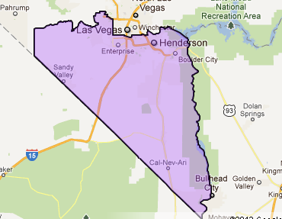

2012 PAID COMMUNICATIONS THEMES
- Oceguera and allies hit Heck on his record of opposing Social Security and women’s health.
- Heck and friends called Oceguera corrupt and a hypocrite that manipulated the public employee system while others were losing their jobs.

