EVENT MEMO

Baltimore, MD

November 8, 2013

DCCC Photo Line and Lunch at the home of Connie Caplan with special guest Vice President Joe Biden

DATE: November 8, 2013

LOCATION: Home of Connie Caplan
7320 Bellona Avenue
Baltimore, MD 21212

TIME: 1:00PM-2:30PM

FROM: Missy Kurek
DCCC Deputy Executive Director of Finance

- PURPOSE:

This is a lunch benefitting the Democratic Congressional Campaign Committee at the home of Connie Caplan with Vice President Joe Biden. The lunch will have 45 attendees, with all attendees participating in a photo line with Vice President Biden directly before sitting for lunch. Lunch guests were asked to contribute $10,000 to the DCCC to attend this event. All Members of the House Democratic Maryland Delegation were invited to attend.

- PARTICIPANTS:

- YOU
- Connie Caplan, host
- House Democratic Leader Nancy Pelosi
- Congressman Dutch Ruppersberger (MD-02) & son, Cory Ruppersberger
- Congressman John Sarbanes (MD-03) & wife, Dina Sarbanes
- Senator Paul Sarbanes, father of Congressman John Sarbanes
- Congressman Chris Van Hollen (MD-08)
- 45 photoline & luncheon participants
.
- PRESS PLAN:

This event will be CLOSED press.

- SEQUENCE OF EVENTS:

12:15 p.m. Call time for Photo Line & Luncheon guests—guests mix and mingle upon arrival

1:00 p.m. YOU arrive at Caplan residence, greet Host Connie Caplan, Leader Pelosi, Congressman Ruppersberger, Congressman Sarbanes and Congressman Van Hollen and proceed to the photo-line

1:05 p.m. Photo line. Caplan family first in photo line

1:25 p.m. YOU conclude photo line
*As guests come out of photo line they are ushered to their seats at lunch

1:30 p.m. Host Connie Caplan welcomes guests and introduces Leader Nancy Pelosi

1:32 p.m. Leader Nancy Pelosi makes remarks and introduces Congressman Ruppersberger

1:35 p.m. Congressman Ruppersberger makes brief remarks and introduces YOU.

1:38 p.m. YOU make remarks and take Q & A

2:05 p.m. Leader Pelosi closes program by giving YOU a birthday cake

2:10 p.m. YOU depart

2:35 p.m. Guests depart

- REMARKS/TALKING POINTS:

None.

- ATTACHMENTS:

- Host Biography
- Attendee Biographies

HOST BIOGRAPHY

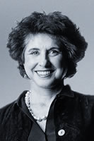
Constance “Connie” Caplan
Constance R. Caplan is Chairman of The Time Group, a real estate investment company in Baltimore, Maryland. She received her Bachelor of Arts degree in American Civilization from Goucher College and Master’s Degree in Political Science from Johns Hopkins University. She is a Trustee Emeritus of the Johns Hopkins University, and member of the Boards of Directors of Johns Hopkins Medicine, Downtown Partnership, The Baltimore Symphony, Honorary Trustee of the Community Foundation of Baltimore, and the Founder and Chair of the Mount Vernon Cultural District in Baltimore. She is also a member of the International Council of the Museum of Modern Art and is now chair of the development committee that is actively trying to raise funds for the restoration of Baltimore’s Washington Monument.

Caplan Family Members Attending:
Mark Caplan, Connie Caplan’s son
Cathy Caplan, Connie Caplan’s daughter
Jonathan Caplan, Connie Caplan’s son
Angus Cook, Partner of Jonathan Cook
Alice Caplan, Connie Caplan’s granddaughter, age 14
August Weinbren, Connie Caplan’s grandson, age 17
Caswell Weinbren, Connie Caplan’s grandson, age 26

MEMBERS & VIPs BIOGRAPHIES
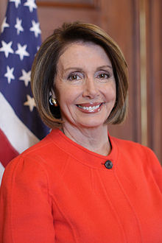
Leader Nancy Pelosi
Nancy Pelosi, the Democratic Leader of the U.S. House of Representatives for the 113th Congress, is focused on strengthening America's middle class and creating jobs, reforming the political system to create clean campaigns and fair elections, enacting comprehensive immigration reform, and ensuring safety in America’s communities, neighborhoods and schools. From 2007 to 2011, Pelosi served as Speaker of the House, the first woman to do so in American history.
For 25 years, Leader Pelosi has represented San Francisco, California's 12th District, in Congress. She first made history when House Democrats elected her the first woman to lead a major political party. She has led House Democrats for a decade and previously served as House Democratic Whip.
Under the leadership of Pelosi, the 111th Congress was heralded as "one of the most productive Congresses in history" by Congressional scholar Norman Ornstein. President Barack Obama called Speaker Pelosi “an extraordinary leader for the American people," and the Christian Science Monitor wrote: “…make no mistake: Nancy Pelosi is the most powerful woman in American politics and the most powerful House Speaker since Sam Rayburn a half century ago.”
At a ceremony in Seneca Falls on October 12, 2013, the National Women’s Hall of Fame inducted nine outstanding women – including House Democratic Leader Nancy Pelosi.
Pelosi comes from a strong family tradition of public service. Her late father, Thomas D'Alesandro Jr., served as Mayor of Baltimore for 12 years, after representing the city for five terms in Congress. Her brother, Thomas D'Alesandro III, also served as Mayor of Baltimore. She graduated from Trinity College in Washington, D.C. She and her husband, Paul Pelosi, a native of San Francisco, have five grown children and nine grandchildren.
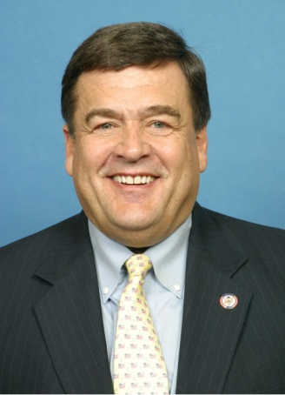
Congressman Dutch Ruppersberger
Congressman C.A. Dutch Ruppersberger is serving his sixth term in the United States House of Representatives for the citizens of Maryland’s 2nd District. Maryland’s 2nd District includes parts of Baltimore City as well as Baltimore, Anne Arundel, Harford and Howard Counties. It is a vital center of trade and commerce for the state and national economy and includes the Port of Baltimore and the thousands of businesses and manufacturing concerns dependent on it. The 2nd District is also home to the National Security Agency, Fort Meade, federal Cyber Command, Aberdeen Proving Ground, the Coast Guard Yard at Curtis Bay and other installations essential to the country’s national security. Congressman Ruppersberger has served in public office for more than 28 years. He was elected to the Baltimore County Council in 1985 and again in 1989, chosen twice as council chairman. A native of Baltimore City, Congressman Ruppersberger spent his summers as a lifeguard and police officer in Ocean City, Md. He attended Baltimore City College and the University of Maryland College Park, where he played lacrosse. He earned his Juris Doctorate from the University of Baltimore Law School. The Congressman has been married for 44 years to his high school sweetheart, the former Kay Murphy. Together they have two grown children, Cory and Jill, and three grandchildren, Camden, Parker and Libby.

Congressman Ruppersberger has been instrumental in the success of this event. Cory, his son, will be attending the lunch today.

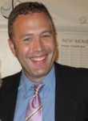
Cory Ruppersberger
Cory is the son of Congressman C.A. Dutch Ruppersberger. Cory lives in Baltimore and works in the mortgage and real estate industry.

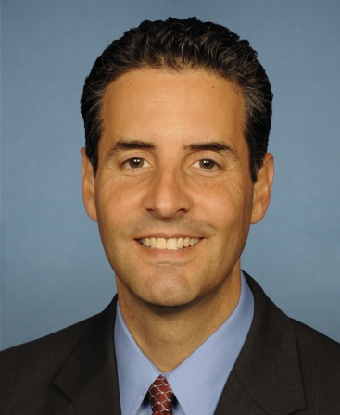
Congressman John Sarbanes & Dina Sarbanes
Congressman John Sarbanes has represented Maryland’s Third District in the United States Congress since 2007. The Third District spans portions of Anne Arundel County, Baltimore City, Baltimore County, Howard County, and Montgomery County. In the House of Representatives, he has been appointed to the Committee on Energy and Commerce where he serves on the Subcommittee on Health and the Subcommittee on Commerce, Manufacturing, and Trade. Born and raised in Baltimore, Congressman Sarbanes and his family live in Towson, giving him the opportunity to drive home every night and hear from the people he serves. Listening to their concerns allows him to better represent Maryland and has shaped his work in the House of Representatives.

Congressman John Sarbanes is attending today’s lunch with his wife, Dina.

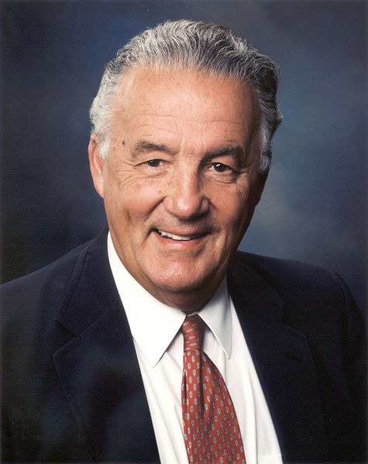
Honorable Paul Sarbanes
Paul Sarbanes served as a member of the United States House of Representatives from 1971 to 1977 and as a United States Senator from 1977 to 2007. Sarbanes is the longest-Serving senator in Maryland history. He did not seek re-election in 2006, when he was succeeded by fellow Democrat Ben Cardin.

Hon. Paul Sarbanes is the father of Congressman John Sarbanes.

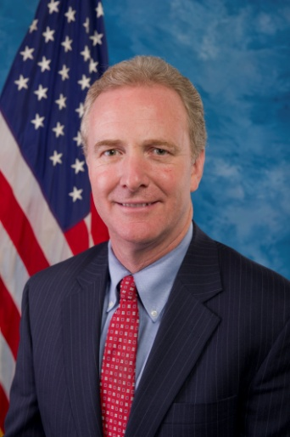
Congressman Chris Van Hollen
Congressman Chris Van Hollen was elected to Congress in 2002. In addition to representing the Eighth District of Maryland and serving in House leadership, Congressman Van Hollen was re-elected by his colleagues in 2012 to serve a second term as the top Democrat on the House Budget Committee. Before his election to the U.S. House of Representatives, Congressman Van Hollen served 4 years in the Maryland House of Delegates and 8 years in the Maryland Senate. He also worked as an attorney in private practice for 10 years. He is a graduate of Swarthmore College, the John F. Kennedy School of Government at Harvard University, and Georgetown University Law Center. He lives in Kensington, Maryland with his wife, Katherine, and their three children, Anna, Nicholas, and Alexander.

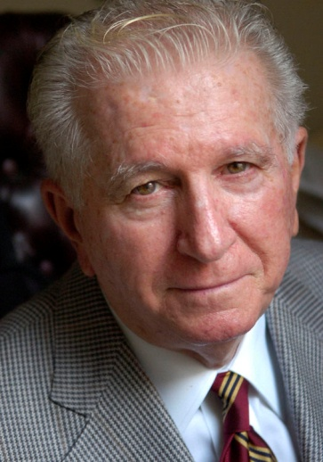
Hon. Tommy & Margie D’Alesandro
Hon. Tommy D’Alesandro is the brother to Leader Nancy Pelosi and the former Mayor of Baltimore from 1967-1971.

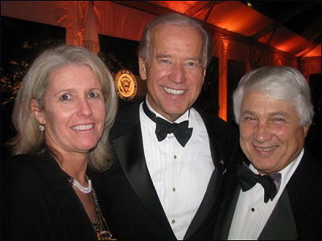
Hon. Ted & Lynn Venetoulius
Ted Venetoulis is the chairman and CEO of Corridor Media Inc., a regional business and political news magazine serving the Baltimore Washington corridor. He is also chairman & CEO of H & V Communications, a global company providing custom marketing and publishing for economic development, transportation, tourism, and convention organizations. Ted served as county executive from Baltimore County from 1974-1978 and was also a gubernatorial candidate.

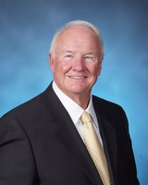
Hon. Frank Kelly
Frank is the Founder and Chairman of Kelly & Associates Insurance Group. He is also a former Maryland State Senator and member of the University of Maryland Board of Regents.

LUNCHEON ATTENDEES:

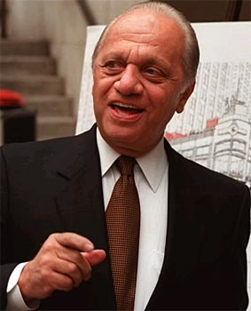
Peter Angelos
Peter G. Angelos has been a Maryland personal injury attorney for over 40 years. He has devoted his professional life to representing those who have suffered from harmful products, medical malpractice, and personal injury. Peter G. Angelos is a formidable opponent and a tireless champion for Baltimore, his hometown. In 1993, he formed a group of Marylanders to purchase the Baltimore Orioles ball club so the team could stay in Baltimore and once again enjoy local ownership. Today, he serves as Chairman of the Board and CEO of the Orioles.


Louis Angelos
Louis, the son of Peter Angelos, is a personal injury, product liability, and pharmaceutical liability at his father’s law firm.

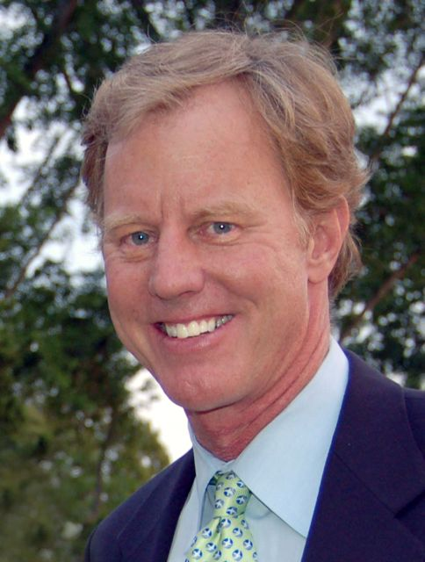
Will Baker
Will has served as the President and CEO of the Chesapeake Bay Foundation since 1982, leading the largest nonprofit conservation organization dedicated solely to preserving, protecting, and restoring the Chesapeake Bay. He is also Vice Chairman of Johns Hopkins Medicine. In 1992, CBF received the Presidential Medal for Environmental Excellence.

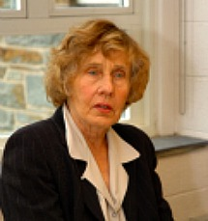
Jean Baker
Jean is a professor of U.S. History at Goucher College in Towson, Maryland. She specializes in 19th Century American history and women’s history. She has published several books including Mary Todd Lincoln: A Biography, Sisters: The American Suffragists, and most recently Margaret Sanger: A Life of Passion. Jean is a Goucher College and Johns Hopkins University alumna.

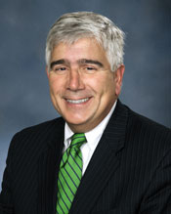
Dr. Stephen Bartlett
Stephen is the chairman of the Department of Surgery at the University of Maryland School of Medicine, and chief of surgery at the UM Medical Center and a Peter Angelos Distinguished Professor. He was recognized as a “Top Doctor” in Baltimore Magazine’s 2008 survey.

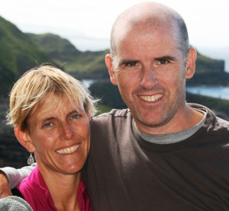
Kerry and Stephen “Steve” Boyle
Steve Boyle is a former Divison 1 basketball player. He currently is a school counselor at Hall High School in West Hartford where he has coached Varsity basketball, track and field, JV soccer and is the head Girls Lacrosse coach. Kerry is a former lacrosse and field hockey players. She is the athletic director at Watkinson School (Ct.) where she also coaches varsity lacrosse. They will be attending with their three daughters: Alannah (17), Michaela (15), and Siobhan (12).


Markie Britton
Markie is an executive coordinator at Tecore. Tecore Networks is a global supplier of 3G, and 4G/LTE mobile network infrastructure.

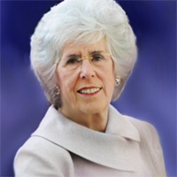
Suzanne “Sue” Cohen
Sue is a retired social activist living in Baltimore, Maryland. Starting in the 1970s, Sue began to take leadership roles in many Baltimore based civic institutions. She is currently the Executive Director of the Nathan and Suzanne Cohen Foundation. Her husband, Nathan, died in 1989. She has two adult daughters: Nancy and Janet.

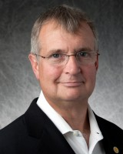
Jack Dwyer
Jack is the President and sole owner of Capital Funding Group, which he founded in 1993. Capital Funding Group is a full-service mortgage banking firm specializing and focusing solely on the healthcare sector. The company provides a broad array of financial services to its clients in the long-term care and hospital industries including permanent, acquisition and construction financing. Prior to establishing Capital Funding Group, Mr. Dwyer was a principal and President of Quaker Capital, L.P. a healthcare financing company.

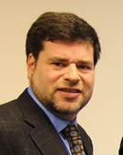
Michael Greenebaum
Michael has been with Greenebaum and Rose Associates since 1987. He has experience in all facets of both commercial and residential real estate development. He is directly responsible for acquisitions, leasing, and managing the Baltimore portfolio.

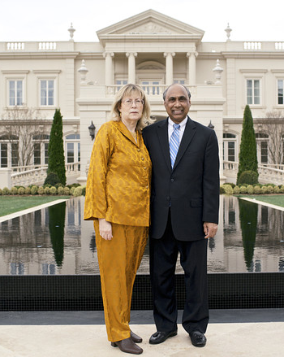
Frank Islam & Debbie Driesman
Frank F. Islam is the Chairman/CEO of FI Investment Group LLC (FIIG), an investment firm he founded in 2007. FIIG focuses on providing growth capital to emerging companies, as well as managing specialized and branded funds. Debbie is retired and is active in a number of local charities through her work on the Frank Islam & Debbie Driesman Foundation.

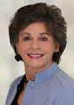
Deborah Jennings
Deborah, chair of DLA Pipers’ Environmental Group, practices environmental law and energy law and litigation. She has extensive experience with litigation and negotiations that affect the environment relating to air, water and hazardous waste permit issues, as well as transportation, cleanup and disposal of hazardous substances. In recent years, a primary focus of her practice has been on Clean Air Act issues that affect the environment, particularly those associated with siting and modifying major air sources and evolving law throughout the United States and policies to address ozone, acid rain and climate change. Deborah has been named a Maryland Super Lawyer and has been listed in The Best Lawyers in America for the past 17 years for her practice of environmental law.

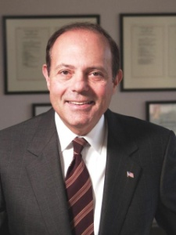
Eugene “Gene” Ludwig
Gene is the founder and CEO of Promontory Financial Group, a trusted adviser to many of the world’s leading financial companies. He is widely recognized as a farsighted thinker o the most pressing issues confronting financial services. Before founding Promontory, Gene served under President Clinton as U.S. comptroller of the currency and was vice chairman and senior control officer of Bankers Trust/Deutsche Bank.

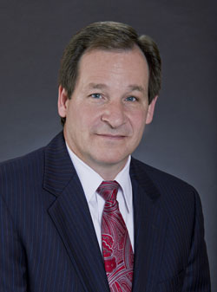
Lawrence Maykrantz
Lawrence Maykrantz is the President of St. John Properties. Lawrence has been with St. John Properties since 1982 and was appointed as President in March 2011. He oversees day-to-day functions of St. John Properties, with specific responsibilities including all phases of development, asset management, marketing, leasing and financial operations. Lawrence holds a bachelor’s degree in accounting, an M.B.A. from the University of Baltimore, and is a certified public accountant.

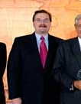
Wayne Rogers
Wayne L. Rogers has been Chairman and Chief Executive Officer of Green Energy Acquisition Corp., since its inception in November 2007. Mr. Rogers also serves as Chief Financial Officer, Principal Accounting Officer and Secretary of Green Energy Acquisition Corp. Mr. Rogers has been included in a number of trade missions, including Commerce Secretary Daley's mission to India in 1997 and President Clinton's historic visit to India in 2000. Mr. Rogers served as Chairman of Maryland Governor Martin O'Malley's Energy Transition Team.


Jay Salkini
Jay Salkini is the founder, president, and CEO of Tecore Networks. He envisioned, developed and patented a wireless technology that has been installed in networks around the globe. He developed significant early experience in wireless communication, which was a nascent field when he started, but which has since become one of the fastest growing industries worldwide.

Raj Sharma
Raj Sharma is the Founder & CEO of Censeo Consulting Group. Censeo is a government contractor group that advises federal agencies on how to do acquisitions more effectively. Prior to Censeo, Raj held several sourcing and supply chain management positions with Booz Allen Hamilton and FreeMarkets (now part of Ariba).

