«Mailname»
«Address_1»
«Address_2»
«City», «State» «Zip»

Dear «Salutation»,

This November in voting booths across the country, Americans will ask one question, “Who’s on our side?”

From the budget to health care to immigration reform, the contrast in priorities makes the answer to this question crystal clear. House Democrats are standing on the side of hardworking families, working to build an economy that works for all Americans. Meanwhile, Republicans have offered nothing but series of wasteful political stunts to appease their base– Speaker Boehner’s frivolous lawsuit, the Benghazi witch-hunt hearings—while asking middle class families to pay the price.

We know our message of economic opportunity resonates with our base and Independents alike, and we must continue to build resources to support the Members and candidates who will carry that message. Because of your support, we are now in our strongest-ever financial position. We continue to out-raise the NRCC and that advantage translates directly into an advantage on the airwaves—we have reserved more than $14 million more in fall TV ad time than Republicans, in ten additional districts.

Your support will allow us to continue this momentum and continue to build an advantage supporting our Members and candidates. I hope you will join me in this effort by making a contribution of «Target» to the DCCC.

I am so grateful for your friendship and ongoing support. Together, we will elect more House Democrats, expanding our dynamic and diverse House Democratic caucus in November.

Best regards,
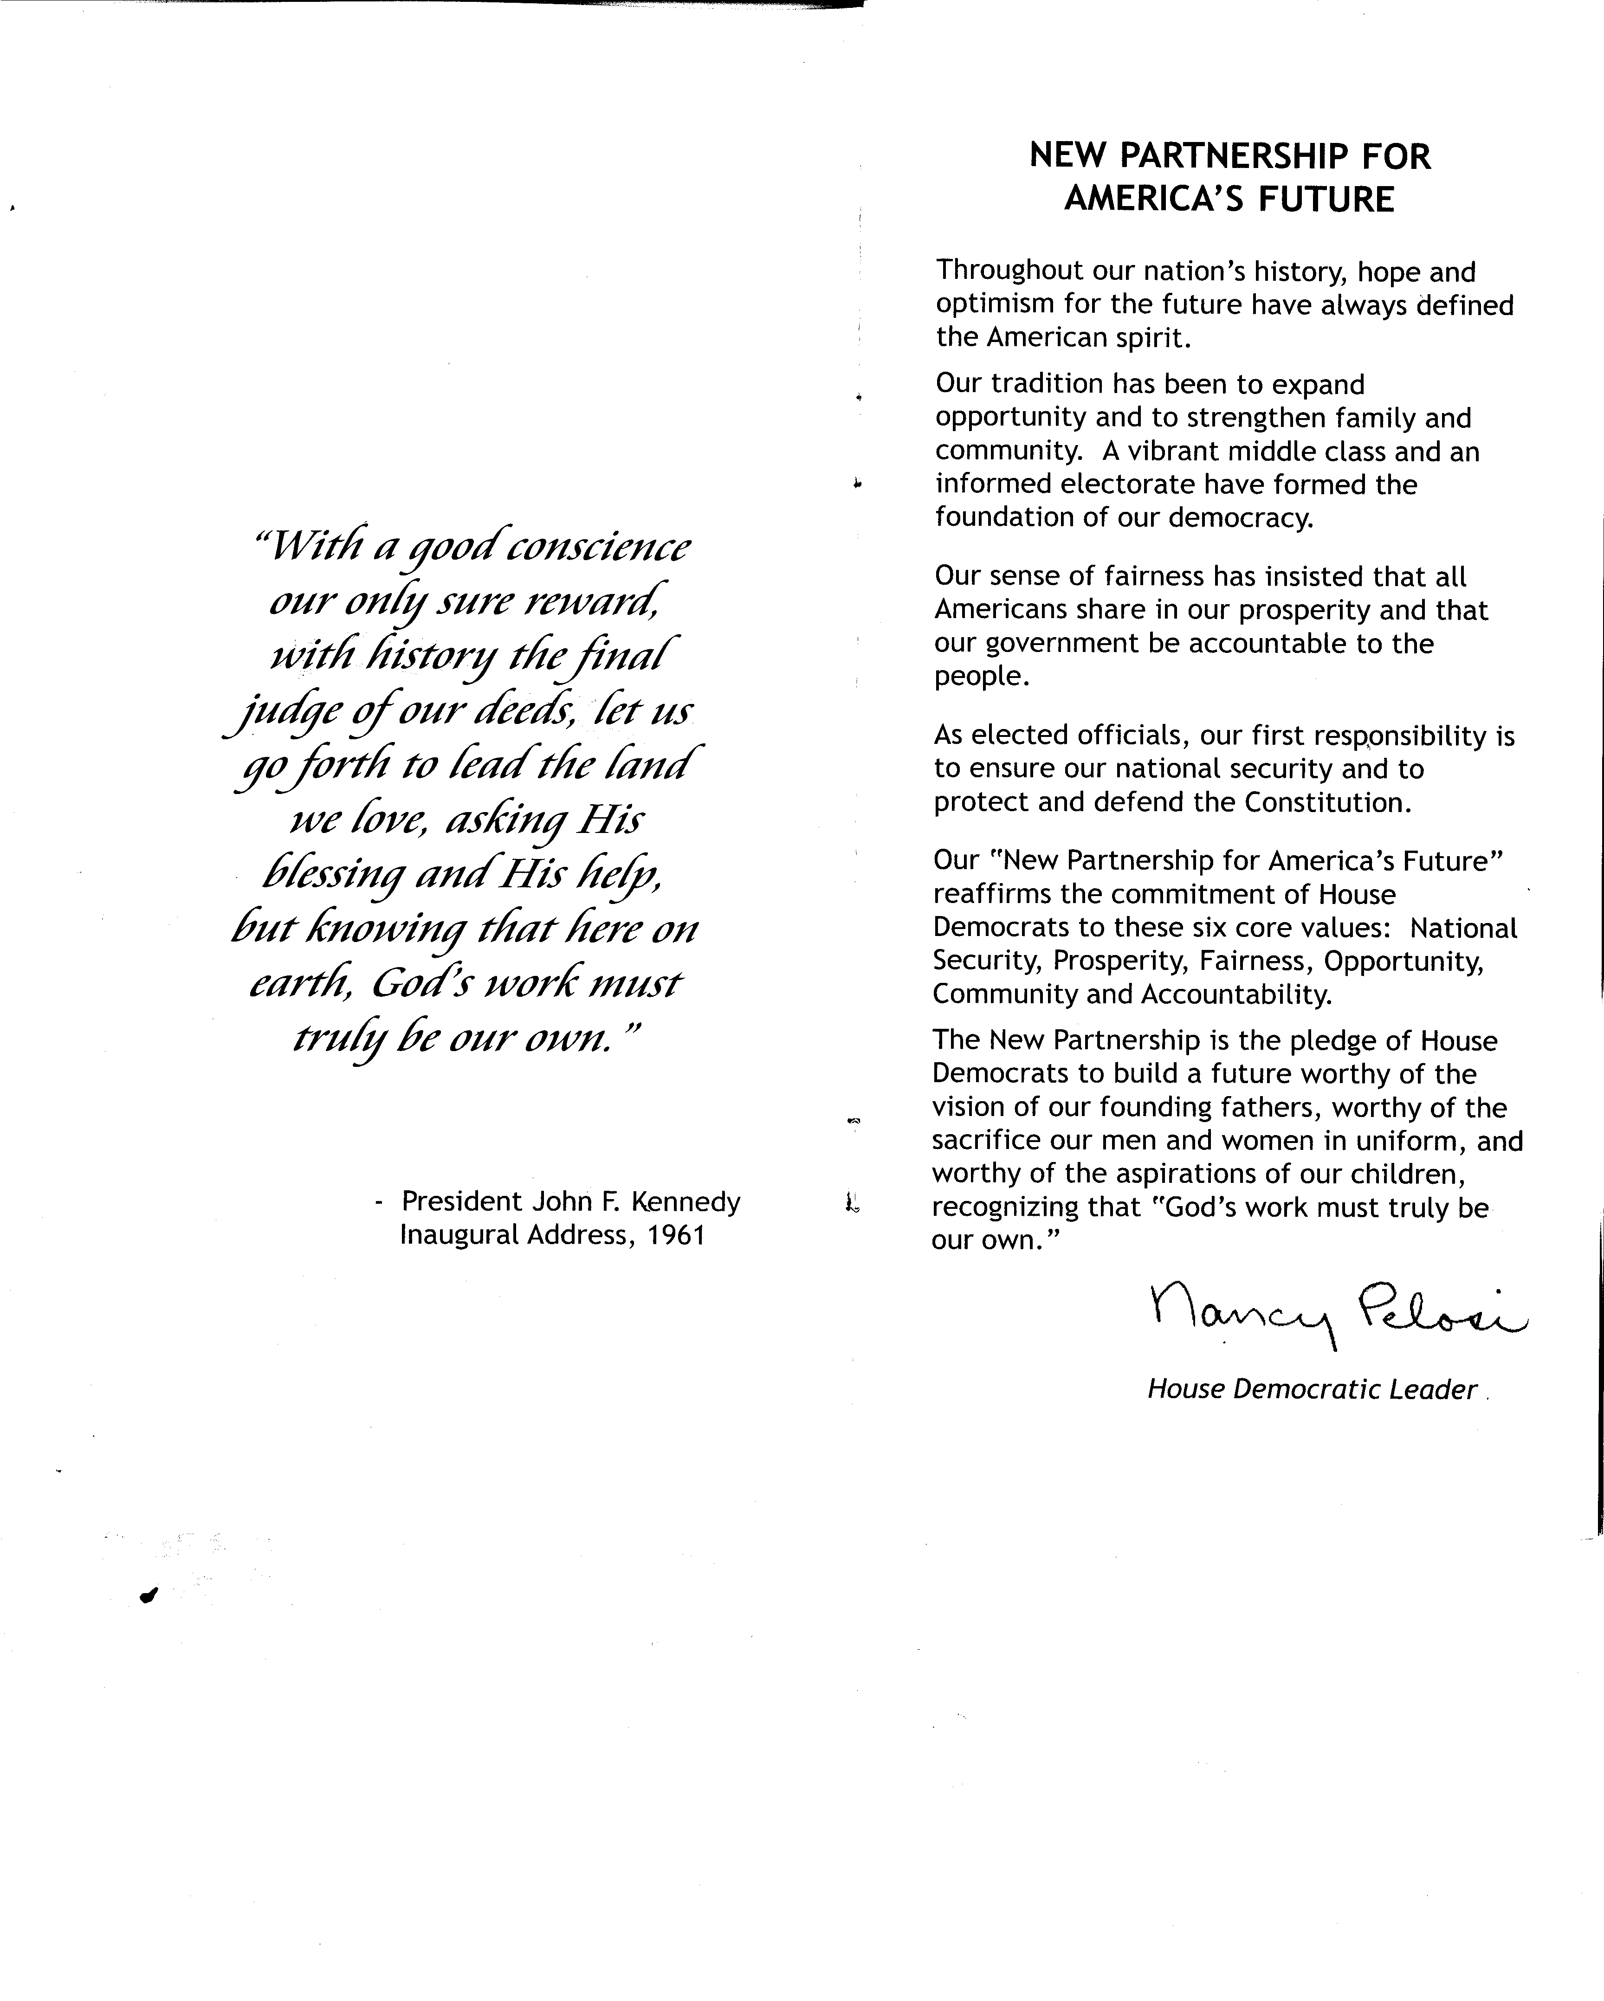

Nancy Pelosi

